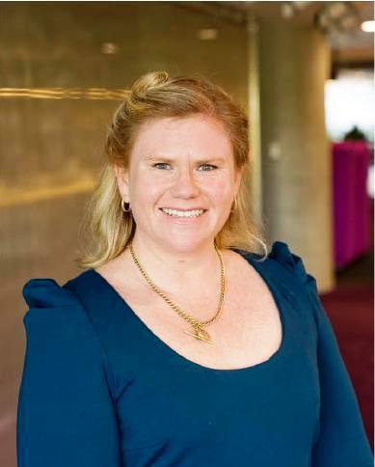
By Kate Morris, Special Projects Director
Time to Reflect.

With this being the last article I write as the Special Projects Director I wanted to take some time to reflect on the last 2 years I have been on the board and what I have gained from the experience.
It takes commitment to volunteer to a cause you care about. When I started out it was actually to be able to attend an event that had reached capacity. I started out supporting our chapter events and greeting members as they walked in the door. Seeing first hand all the work happening gave me the idea to help out with marketing and our online presence. This was where I cut my teeth so to speak on coming up with ways to support our members and grow the PMI Sydney Chapter in sponsorship and presence in the community.
Most people don’t know that I have a very big problem with public speaking. When I was asked to be the Events Director I had such huge shoes to fill after seeing Amany Nuseibeh running the show. Taking on that challenge meant I had to deal with my fears head on and grow as a person. It was so great to be able to meet with members and speakers alike, growing my network and professional contacts. The practice of standing in front of peers and presenting has helped me profoundly get over my stage fright.
Volunteers do not necessarily have the time; they just have the heart.
Elizabeth Andrew

I still remember fondly the night Julia Checchia cornered me about her idea for a PMI Australia Conference. I honestly had no idea what I was getting myself into and I'm so glad I didn’t! I mean who would have taken on such a large scale project representing 6 chapters for the first time without any conference experience? The 18 months spent preparing for the conference and working with some fantastic project managers I know has made me a better project professional. Being the Convenor for the inaugural conference will remain a key highlight of my career and something I will forever be grateful and proud of. It was a catalyst for the 6 chapters to work more closely together and I can’t wait to see all the great things being prepared for the 2nd conference to be held in Melbourne next year.
I think about the group of dedicated board members I have worked with. It’s inspiring to see such great minds come together for the greater good. We all believe in promoting the art, science and benefit of project management and work tirelessly to deliver on that for members. Though all of us have full time roles and families to look after, we all are passionate about making the difference and giving back to the project profession. It was great to see the passion for the profession in other chapters around the world. Participating in the Asia Pacific LIM this year highlighted how leveraging knowledge from other chapters grows us all and be a force to be reckoned with.
It was so good to see us go to an election this year. It means we have succeeded in inspiring our members to be active and want to make a difference. It’s this passion and enthusiasm that will ensure PMI Sydney Chapter continues to thrive and prosper with engaged and focused directors leading the way.
As for me now, I'm studying for my PMP. I’ve finally got to it on my list of things I want to achieve. I know PMI will never be far away – I will still remain an active volunteer and support our initiatives going forward.
Thank you for supporting me during my time as a PMI Sydney Board Director – it truly has been a life changing experience and one I will always look back fondly on.

